Cordex Materials List – Major Components

|  |  |  |  |  |  |
| --- | --- | --- | --- | --- | --- |
| Part description | Manufacturer,  Part Number | Distributor,  Part Number | Cost per unit | Number of units | Ordering info: Website and/or salesperson. |
|  |  |  |  |  |  |
| Gage pressure sensor | Sensortechnics  HCEM500GUH9P3 | Same as manufacturer | $64.00 | 1 | [www.sensortechnics.com](http://www.sensortechnics.com)  John Maguire, Ph:508.339.2955  Email: [John.Maguire@sensortechnics.com](mailto:John.Maguire@sensortechnics.com) |
| Absolute pressure sensor | Sensortechnics  HDIB002AUY8H5 | Same as manufacturer | $60.59 | 1 | [www.sensortechnics.com](http://www.sensortechnics.com)  John Maguire, Ph:508.339.2955  Email: [John.Maguire@sensortechnics.com](mailto:John.Maguire@sensortechnics.com) |
| Flow sensor | SENSIRION | Same as manufacturer  SFM3000 | $200.00 | 1 | [www.sensirion.com](http://www.sensirion.com)  Ohlan Silpachi, 805-409-4484  Ohlan.silpachi@sensirioninc.com |
| Pump | Okenseiko  P54E01R | Same as manufacturer | $116.07 | 1 | [www.okenseiko.com](http://www.xavitech.com/)  Tomoaki Anazawa  +81 42 379 2211  Email: oken@okenseiko.com |
| Restrictor Valve1 | Bird Precision  RB-82426-22061 | Same as manufacturer | See first footnote. | 1 | <http://birdprecision.com/>  Paul Baillio, Ph: 781-894-0160/ 800-454-7369  Email: sales@birdprecision.com |
| Solenoid Release Valve2  (Qty:2) | Parker Hannifin  X-1-12-S-F | Same as manufacturer | $37.50 | 1 | <http://www.parker.com/>  Bob Reilly, Ph: 603-578-1562  Email: bob.reilly@parker.com |

1See above

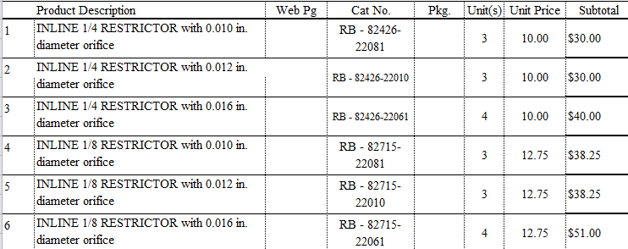

2When ordering each solenoid release valve from Parker Hannifin, also order 2 units of each of these associated accessories: Retention pins ($0.40 each).